K. R. Mangalam University
School of Engineering and Technology


Operating System Lab File Course Code: ENCS351

Submitted by Submitted To
Name: Swapnil Paroda Dr. Satinder Pal Singh Roll No.: 2301010394
Program: BTech CSE Section: F
Session: 2025/26 Date: 30/11/2025

Index

Serial No. | Assignments
1. | Assignment 1
1. | 1.1 Process Creation Utility.
1. | 1.2 Command Execution Using exec ().
1. | 1.3 Zombie & Orphan Processes.
1. | 1.4 Inspecting Process Info from /proc.
2. | Assignment 2
2. | 2.1 Write a Python script to simulate a basic system startup sequence.
2. | 2.2 Use the multiprocessing module to create at least two child processes  that perform dummy tasks.
2. | 2.3 Implement proper logging to track process start and end times.
2. | 2.4 Generate a log file (process_log.txt) to reflect system-like behaviour.
3. | Assignment 3
3. | 3.1 CPU Scheduling with Gantt Chart.
3. | 3.2 Sequential File Allocation.
3. | 3.3 Indexed File Allocation.
3. | 3.4 Contiguous Memory Allocation.
4. | Assignment 4
4. | 4.1 Batch Processing Simulation (Python).
4. | 4.2 System Startup and Logging.
4. | 4.3 System Calls and IPC (Python - fork, exec, pipe).
4. | 4.4 VM Detection and Shell Interaction.

Task 1.1: Process Creation Utility

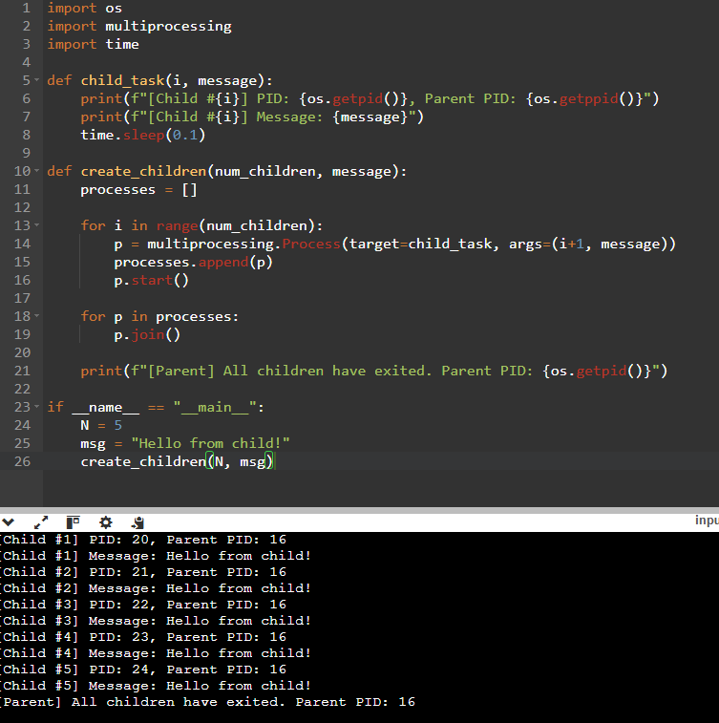

Task 1.2: Command Execution Using exec()
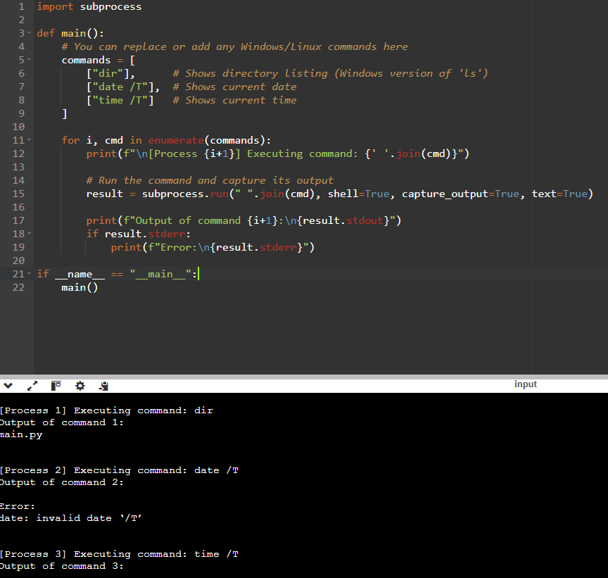

Task 1.3: Zombie & Orphan Processes
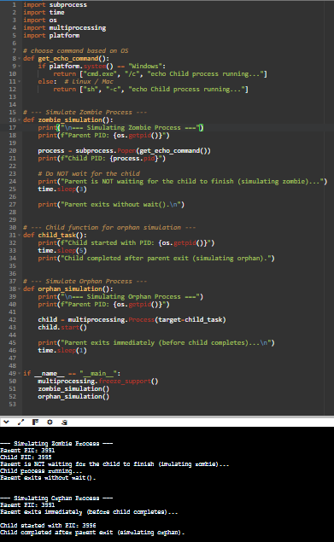

Task 1.4: Inspecting Process Info from /proc
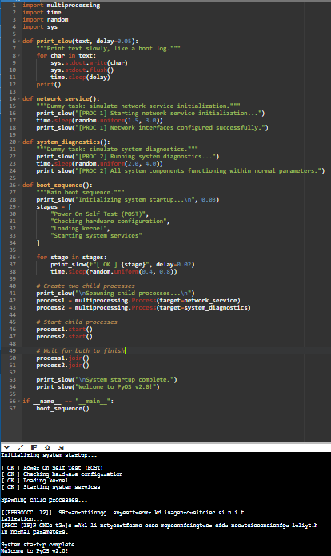

Task 2.1 Write a Python script to simulate a basic system startup sequence.
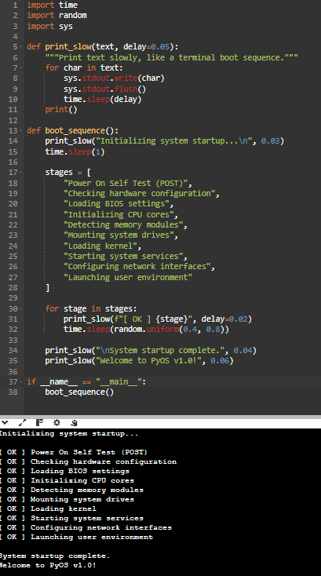

Task 2.2 : Use the multiprocessing module to create at least two child processes that perform dummy tasks.
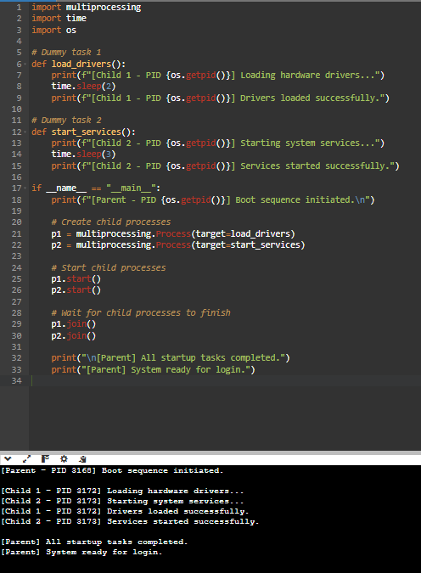

Task 2.3 Implement proper logging to track process start and end times
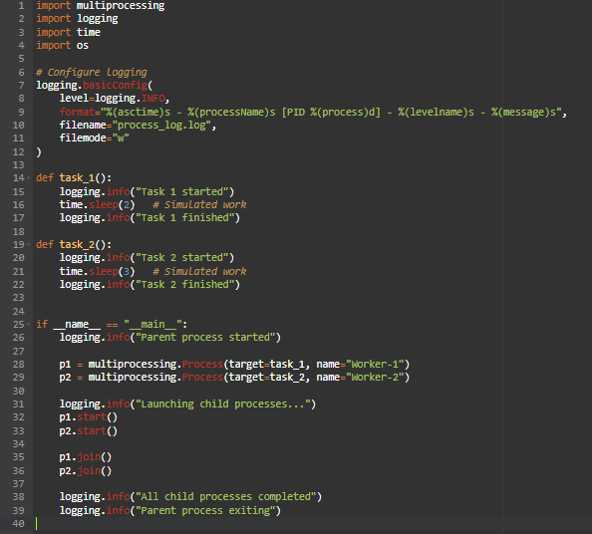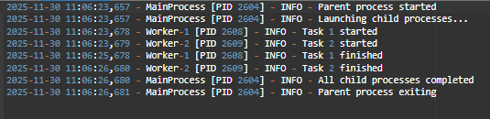

Task 2.4: Generate a log file (process_log.txt) to reflect system-like behaviour
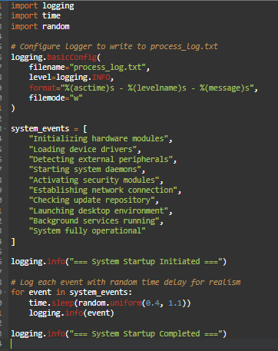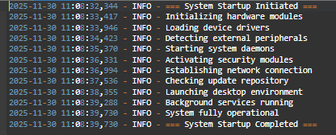

Task 3.1 CPU Scheduling with Gantt Chart
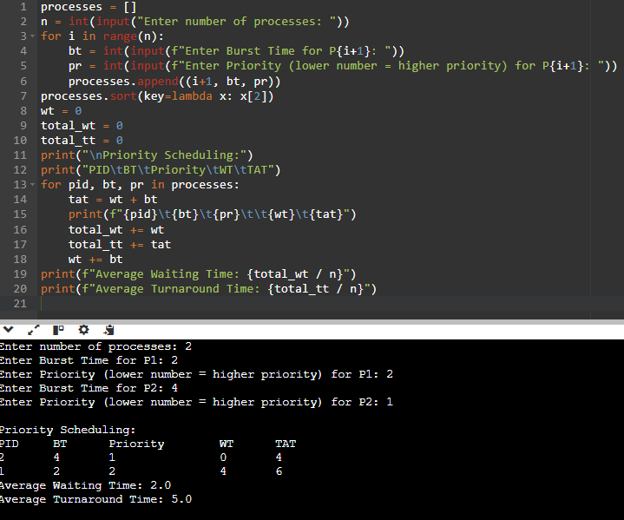

Task 3.2 Sequential File Allocation.
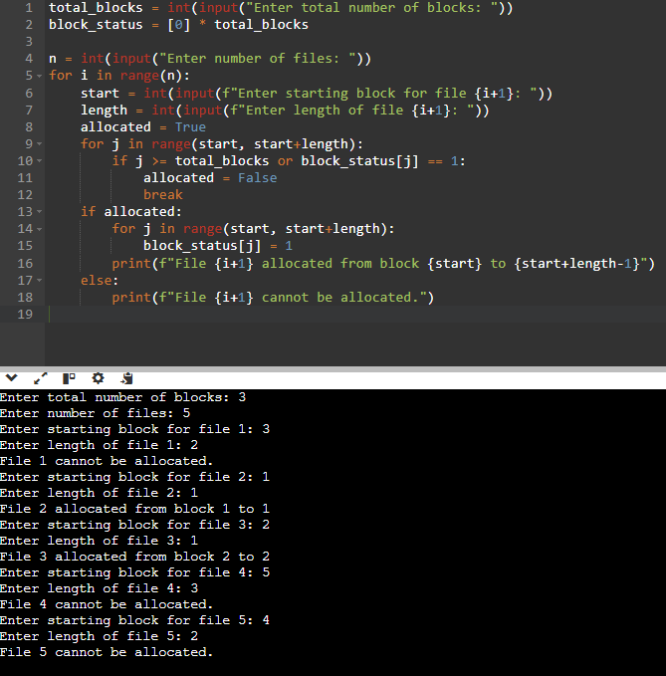

Task 3.3 Indexed File Allocation
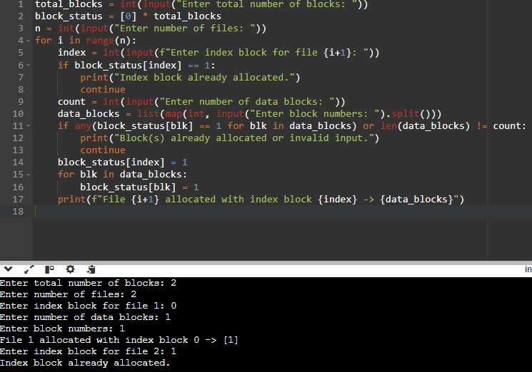

Task 3.4 Contiguous Memory Allocation
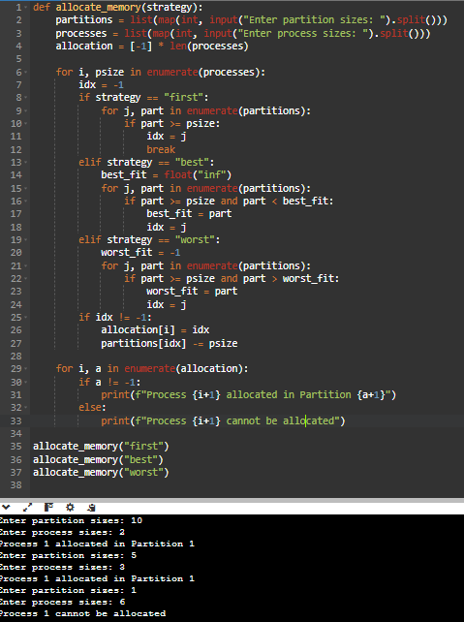

Task 4.1: Batch Processing Simulation (Python)

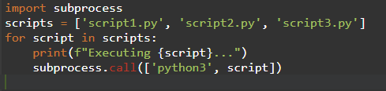

Task 4.2: System Startup and Logging
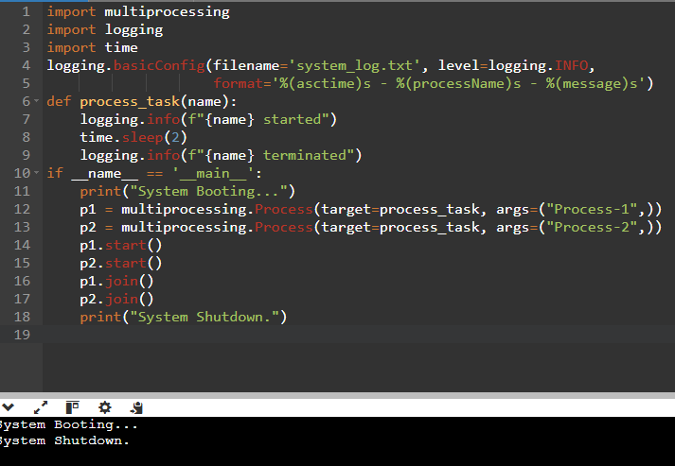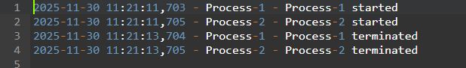

Task 4.3: System Calls and IPC (Python - fork, exec, pipe)

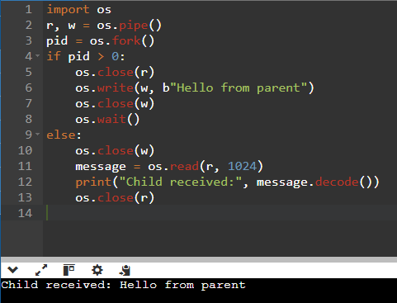

Task 4.4: VM Detection and Shell Interaction
